Standard Operating Procedure for Power Supply NGL202

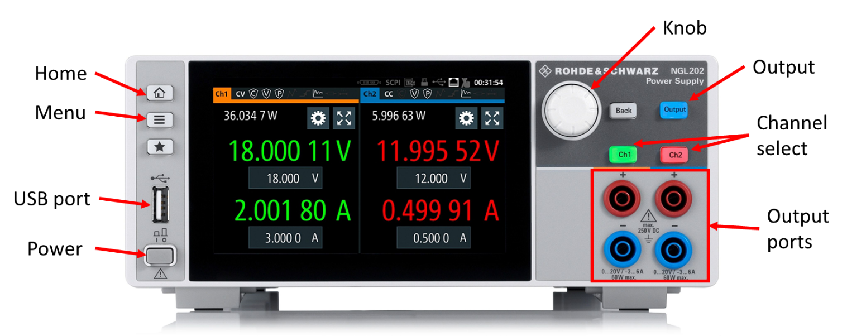

Figure 1: Rohde & Schwarz NGL202 Power Supply

Contents

Specifications 1

Procedure 1

Sourcing voltage and measuring current to a resistance using NGL202 1

Constant voltage mode in NGL202 2

Constant current mode in NGL202 2

Constant current source mode examples 3

1 mA constant current source 3

10 mA constant current source 3

100 mA constant current source 3

Remote Control 3

# 

# Specifications

1. Maximum output voltage: 20.05 V (DC)
2. Minimum output voltage: 1 mV
3. Maximum output current
   1. If voltage is less than or equal to 6 V: 6.01 A
   2. If voltage is higher than 6 V: 3.01 A
4. Minimum output current: 1mA
5. Maximum power output: 120 W
6. Two-channel instrument

# Procedure

## Sourcing voltage and measuring current to a resistance using NGL202

1. Connect the power supply to the source and then press the power key of the NGL202
2. The device has two channels, we will work on CH1, nevertheless procedure is same for both channels
3. Connect the Red and Blue banana cables to the CH1 ‘+’ and ‘-’ terminal respectively
4. Take a 1k $Ω$ resistance (or any desired resistance), and connect it to the banana cables by means of crocodile clips
5. Now click on the [SETTINGS] icon on the screen of CH1, then click on [OUTPUT] icon, then go to [OUTPUT MODE], and make sure it is in [AUTO] mode
6. Now come back to the home screen by pressing the [HOME] button available on the front panel
7. Enter your source voltage as 1V (give your desired voltage), and the current limit as 1A (give your desired current limit) in the CH1 display
8. Press the [CH1] button and then the [OUTPUT] button available on the front panel
9. The fonts will be in green, you can see the voltage applied and the current measured, for 1k $Ω$ resistance, for 1V source applied, 1mA current will be measured

## 

## Constant voltage mode in NGL202

Connect the SMU (or any other sourcing device) to NGL202|Channel font will be in green

1. SOURCE MODE: If the load voltage (applied in SMU) is less than the set voltage in the power supply, the channel is in source mode, current flows from NGL202 to SMU
2. SINK MODE: If the load voltage (applied in SMU) is more than the set voltage, the channel is in sink mode, the current flows from the SMU to NGL202

## Constant current mode in NGL202

Connect the SMU (or any other sourcing device) to NGL202|Channel font will be in red

1. If the current flowing out of NGL202 is more than set current, than the device will be in constant current mode, and will cap the current flowing out to the set current

Procedure:

1. Take a resistor, let’s say 100 $Ω$, connect it to the NGL202 with the help of crocodile clips and banana cables
2. Apply some voltage say 1V, measure the current, which will be 0.01A
3. Now set the current limit to less than 0.01A, say 1mA
4. Now switch on the output, the fonts will be in red, and 1mA current will be given out

# Constant current source mode examples

## 1 mA constant current source

1. Connect 1 k $Ω$ resistor, set the voltage to 2 V
2. Set the current limit to 1 mA, and wait for few seconds

## 10 mA constant current source

1. Connect 1 k $Ω$ resistor, set the voltage to 10 V
2. Set the current limit to 10 mA, and wait for few seconds

## 100 mA constant current source

1. Connect 100 $Ω$ resistor, set the voltage to 10 V
2. Set the current limit to 100 mA, and wait for few seconds

Note:

Sometimes it may happen that even after setting the current limit, the fonts are still in green (i.e., in Constant source mode), in such case, usually waiting for a few seconds solves the problem, otherwise just increase the voltage value by a small amount (e.g., 5V $→$ 5.2V)

# Remote Control

The device can be virtually control through a computer browser over LAN

1. Make sure the NGL202 is connected the LAN hub, and the lab laptop is also connected to the LAN hub (or directly connect the NGL202 and the laptop with a LAN cable)
2. Click on the [MENU] button on the front panel, and click the [INTERFACE] button on the screen
3. Go to [LAN], the IP address of the NGL202 should be visible, if it is not wait for few seconds until the device makes proper connection through LAN and the IP address is visible
4. Open any browser on the lab laptop, and put the IP address of the NGL202 in the address bar, and search
5. The home page of the R&S NGL202 will be visible, and click on the VNC device control
6. A virtual NGL202 frame will be available on the browser, use it to interact with the device